FINAL PROJECT

Antonio Cadavid

Alejandro Suarez

Jairo E. Rodriguez

Juan D. Hernandez

A00354484

A00359653

A00354217

A00356210

CAPSTONE PROJECT

 ICESI UNIVERSITY

Bank Marketing

Problematic context

To create a solution to the problem we will tackle we chose to use the Engineering method to develop following a systematic focus, according to the problem situation.

Based on the description of the engineering method from the book “Introduction to Engineering” from Paul Wright, the following flow diagram has been defined, which steps we will be following during the development of our solution.

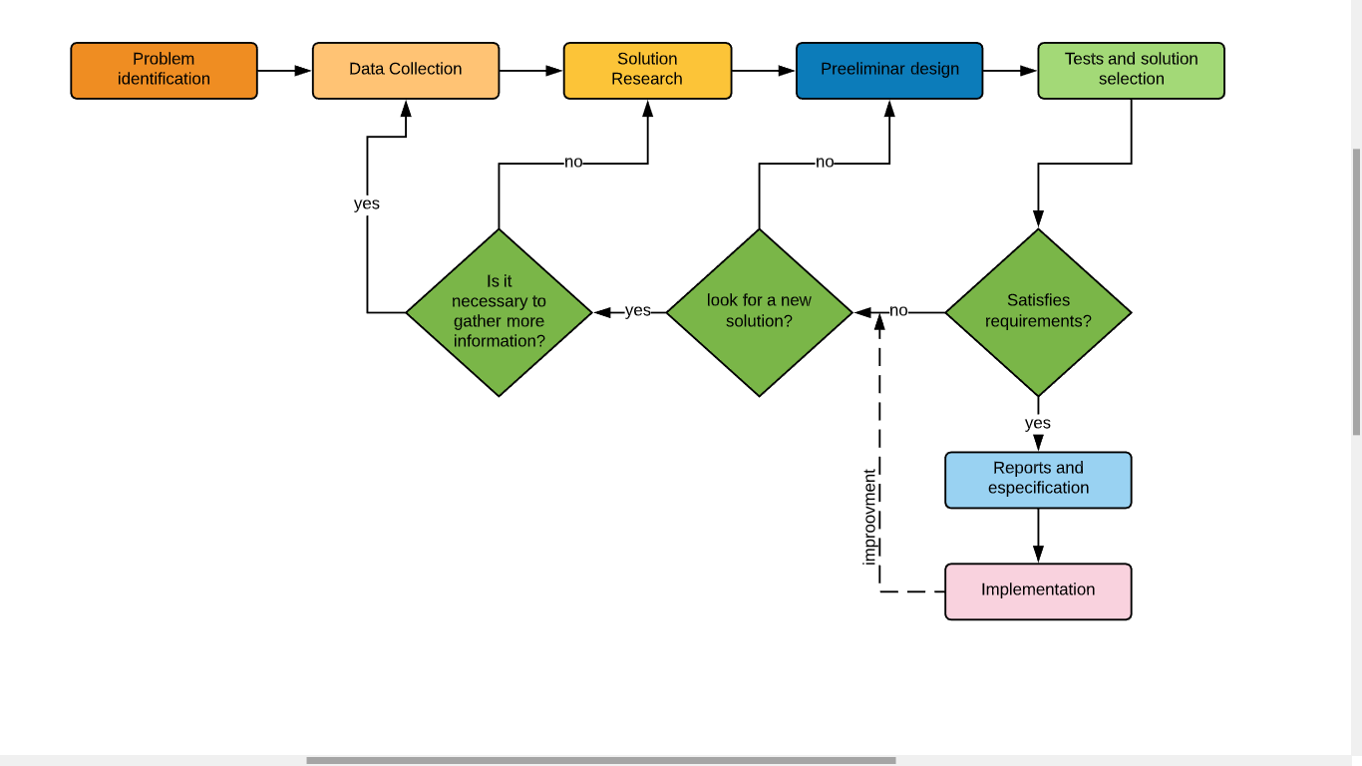

Step 1: Identification of the problem

Problem definition:

The CEO of Wekebank inc has noticed that one particular product in their portfolio is particularly good profit wise, this product is the famous “term deposit”. First of all the CEO wants a piece of software that is able to display the attributes of the clients database in a graphic way so the bank's board can have a better understanding of them. Since the term deposit will generate a lot of revenue for the bank, the CEO needs a custom software module that can determine if a client will or will not acquire a subscription to a term deposit based on his/her particular attributes. The goal is to spot these clients so the marketing team of the bank can focus on them, and develop an aggressive marketing campaign to sell as many term deposits subscriptions as possible.

For this reason the CEO has hired you and your team of engineers to develop a solution to tackle this problem and help the bank to increase its revenue by selling more subscriptions to term deposits.

Identification of the needs:

-The bank needs to visualize the data in a series of charts and graphics.

-The bank needs to filter the information from a desired way.

-The bank needs to determine whether a client will or will not acquire a subscription to a term deposit.

Step 2: Data collection:

In this step we will compile some information through research in order to understand the problem better and develop a better solution.

**Data set :**

<http://archive.ics.uci.edu/ml/datasets/Bank+Marketing>

Bank Marketing Data Set - year 2014

What Is a Term Deposit?

A term deposit is a fixed-term investment that includes the deposit of money into an account at a financial institution. Term deposit investments usually carry short-term maturities ranging from one month to a few years and will have varying levels of required minimum deposits.

The investor must understand when buying a term deposit that they can withdraw their funds only after the term ends. In some cases, the account holder may allow the investor early termination—or withdrawal—if they give several days notification. Also, there will be a penalty assessed for early termination.

Examples of term deposits include certificates of deposit (CDs) and time deposits.

* A term deposit is a type of deposit account held at a financial institution where money is locked up for some set period of time.
* Term deposits are usually short-term deposits with maturities ranging from one month to a few years.
* Typically, term deposits offer higher interest rates than traditional liquid savings accounts, whereby customers can withdraw their money at any time. (Chen, 2020)

For the sake of the solution it was necessary for us to understand a little bit of what a term deposit really is, that’s why we researched a bit about this financial product. We just find it more comfortable to develop the solution knowing what the bank is really trying to sell, it gives us a more global approach to the understanding of the problem.

Classification:

Since we need to classify variables and infer their classes based on parameters, we find a decision tree really suitable to develop an optimal solution for this problem due its strengths. Decision trees are able to perform classifications without requiring a lot of computation due its recursive nature, that is an advantage due the large amount of records that we will handle, also they are able to generate clear and understandable classification rules, which is pretty important since this solution is implemented and maintained by humans.

But what is a decision tree?

Decision tree

Decision Tree: Decision tree is the most powerful and popular tool for classification and prediction. A Decision tree is a flowchart like tree structure, where each internal node denotes a test on an attribute, each branch represents an outcome of the test, and each leaf node (terminal node) holds a class label.

Construction of Decision Tree:

A tree can be “learned” by splitting the source set into subsets based on an attribute value test. This process is repeated on each derived subset in a recursive manner called recursive partitioning. The recursion is completed when the subset at a node all has the same value of the target variable, or when splitting no longer adds value to the predictions. The construction of decision tree classifier does not require any domain knowledge or parameter setting, and therefore is appropriate for exploratory knowledge discovery. Decision trees can handle high dimensional data. In general decision tree classifier has good accuracy. Decision tree induction is a typical inductive approach to learn knowledge on classification. (Geeks for geeks, 2019)

Decision tree representation:

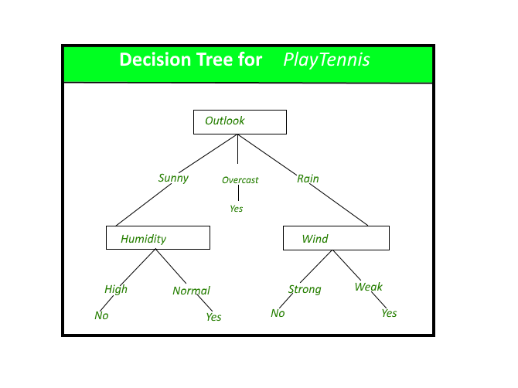

**State of the art:**

Since we chose to implement our own version of a decision tree to classify the variables we reserched to see if there were hardcore tested libraries that have an implementation of a decision tree in order to grasp a better understanding of the data stuctures and algorithms used in the implementation, so our own is a proper one.So here are ones we found and checked.

Decision Tree 3.4.3

This one is a  Python module for decision-tree based classification of multidimensional data.

Module Download page:

https://pypi.org/project/DecisionTree/

Module API:

[*https://engineering.purdue.edu/kak/distDT/DecisionTree-3.4.3.html*](https://engineering.purdue.edu/kak/distDT/DecisionTree-3.4.3.html)

Accord .NET Framework

Is a .NET machine learning framework combined with audio and image processing libraries completely written in C#.

Module Download page:

https://github.com/accord-net/framework

Step 3: Solution research

We will tackle the problem of CEO of Wekebank using different approaches

Alternative 1: In this approach, we will start with an aesthetically pleasing graphic interface for the user where we will ask that select from his directory the database to load the dataset of the company. The information is categorized by columns with: Age, job, marital, education, debit, balance, housing, loan, deposit. The dataset will be displayed by columns and also will allow you to filter by any category that you need: Ex: Category: Age, Data: 20. After that the dataset only shows the data that we ask. Also, the graphic interface has two computer tabs that you can select if you need the dataset or the graphic with the global summary with all of data.

Alternative 2: In this approach, we will start with a simple interface where we will load the default dataset, also can be reduced to don’t have the need to have irrelevant information about the problem and with that reduce the memory use. Also, we will allow that will generate the respective graphics to give you a simple summary about all the information. The program is able to filter by category already defined, but if it is a numerical variable it will show the lower to higher, on the contrary will be lexicographic.

Alternative 3: In this approach, we will start with a complex interface where we will try to show the all information about the Dataset, but what make it different is the way to filter, in the other alternatives, the tool to filter is a ComboBox that have the category to filter, in this case won't be like that, because the program allow to filter only with a clic in the column of the datagrid. If you clic once the data will organize by ascendingly, but is twice descengly. Also the program gives you a summary with a simple graphic to try to remember better the information.

Alternative 4: In this approach, we will start with an interactive interface where the user provides all information that he needs. Like other alternatives, the user searches the dataset that he likes to show, after that the user goes through a checkbox with the category, the program allows to select the category that you like to see about the information. We think that we have more control of all data and regulate the order. Also have the summary with different types of graphics that you need to see.

Alternative 5: In this approach, we will start with a simple interface where the person already loads the Dataset on the program. First the program allows you to organize the information by a specific condition like: Age, birth, etc. and also allows you to filter again if you need. The special of this alternative is in the summary, when you have all the information loads in the program you can select a special graphic to show like a: Circular, bar, waves, etc. and allow to select the information that you need graphic and if you need the data separate or together. The program finish with a simple conclusion about the all graphic that you generate

Step 4: Preliminary design

Step 5: Solution Selection

Step 6: Reports and specification

Specification of the problem (in terms of input / output) or functional and non functional requiremnts:

Functional requirements:

|  |  |
| --- | --- |
| name | R1. Load data |
| summary | The program must be able to load from a csv file.  This data will be manipulated by the program during its execution. |
| in | csv file |
| out | <none> |

|  |  |
| --- | --- |
| name | R2. Display data |
| summary | The program must be able to display the loaded data in a table. |
| in | <None> |
| out | A table with the data of the loaded file. |

|  |  |
| --- | --- |
| name | R3.Filter data |
| summary | The program must be able to filter the data of the table based on a desired attribute ( column of the table). |
| in | the desired attribute. |
| out | a filtered table will be displayed on the screen. |

|  |  |
| --- | --- |
| name | R4.Classify variable |
| summary | The program must be able to classify a variable using a decision tree.  For this particular case the program will classify the clients of the bank which are represented by each of the records from the data table that contains the loaded information. The clases of this problem are yes/no. “Yes” if the client will acquire the subscription to the term deposit and “No” if not. |
| in | a record of the table. |
| out | the class of the variable |

Non Functional requirements:

|  |  |
| --- | --- |
| name | NFR1.Dataset |
| summary | The program must only read the selected dataset in order to run properly. |
|  |  |
|  |  |

Class diagram:

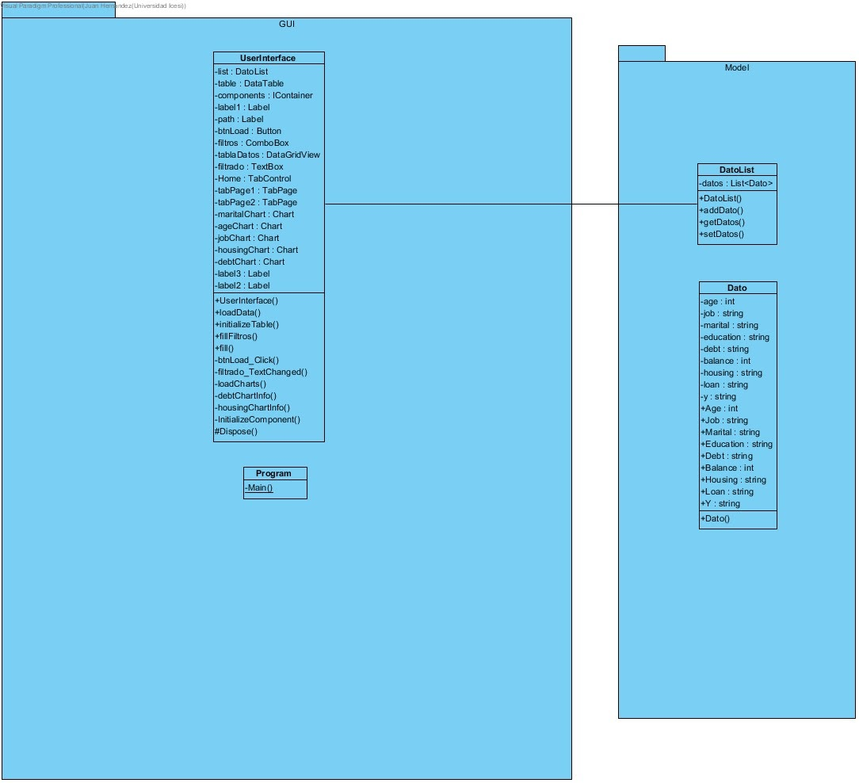

Object Diagram:

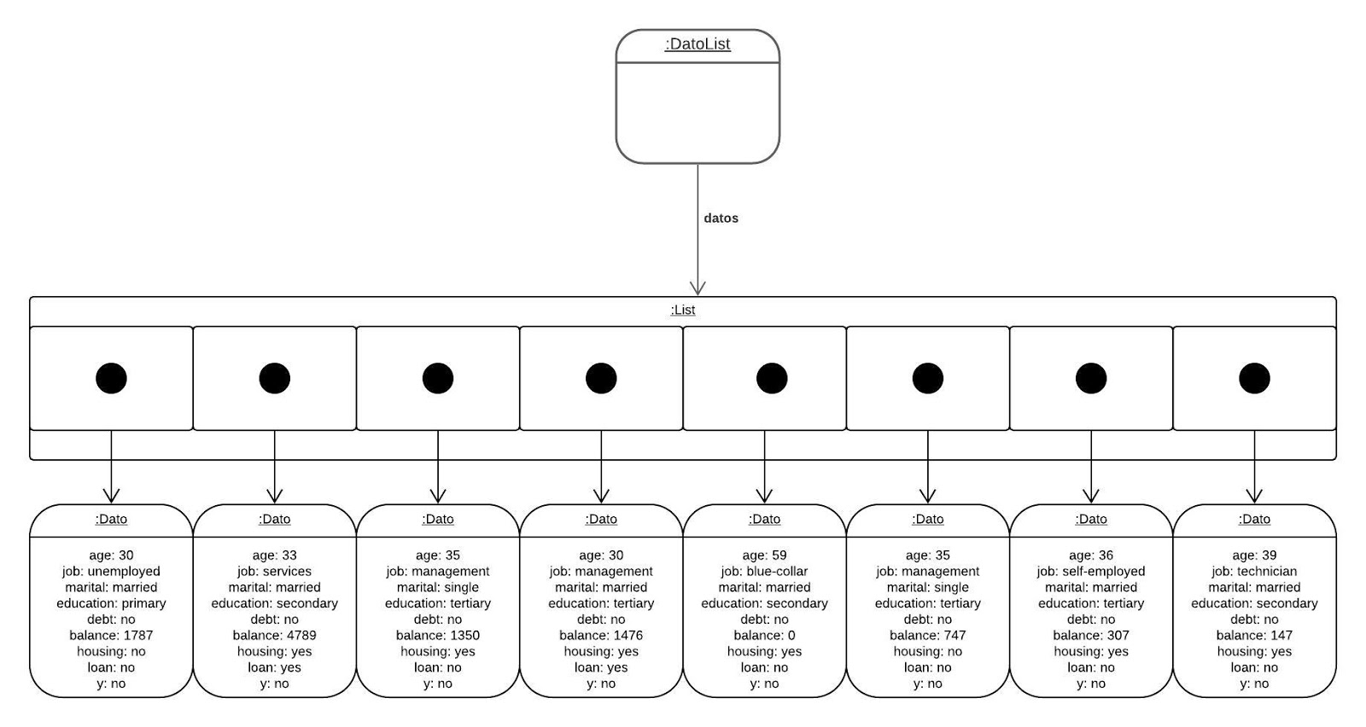

# Bibliography

Chen, J. (16 de 03 de 2020). *www.investopedia.com*. Obtenido de https://www.investopedia.com/terms/t/termdeposit.asp

Geeks for geeks. (2019, 04 17). *www.geeksforgeeks.org*. Retrieved from https://www.geeksforgeeks.org/decision-tree/